Georgia Future Educator
I, ,

am committing to be a successful

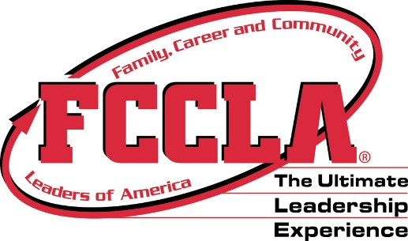
Georgia Educator

on this day,

Tuesday, May 8, 2018

I understand this is not a legal, binding agreement, but a GREAT way to express my commitment to “Educating Georgia’s Future” through my future career pathway!

STUDENT SIGNATURE TEACHER SIGNATURE

